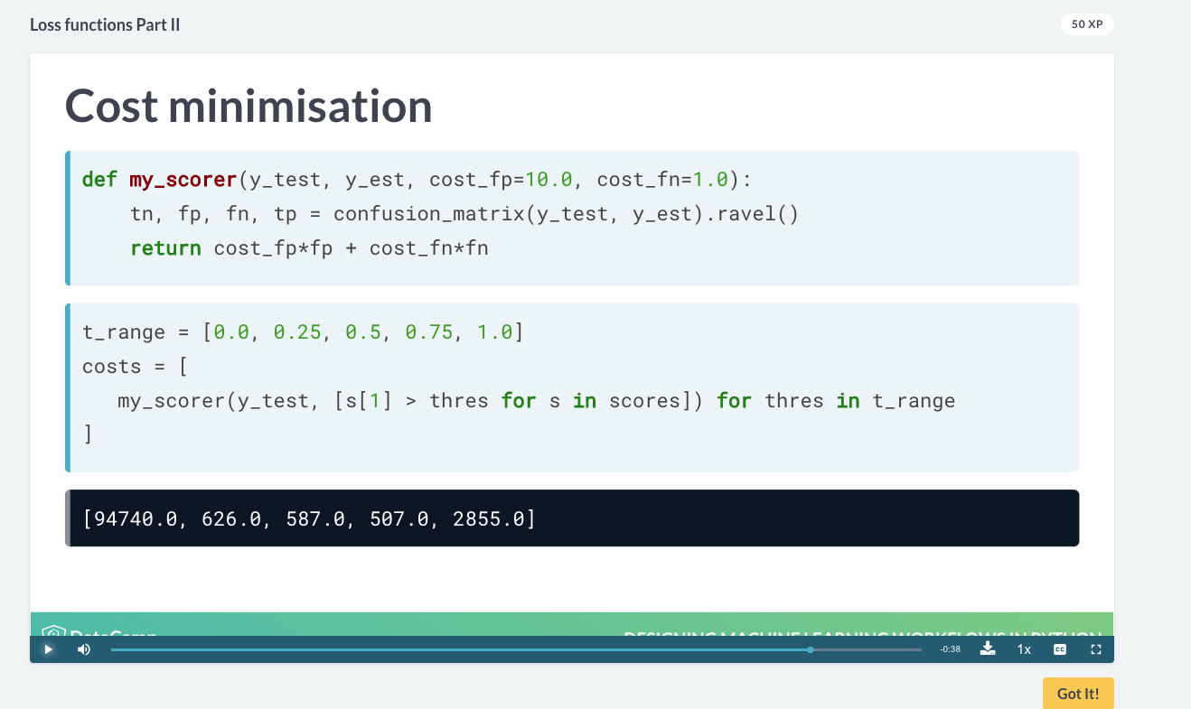

# Create a scorer assigning more cost to false positives

def my_scorer(y_test, y_est, cost_fp=10.0, cost_fn=1.0):

tn, fp, fn, tp = confusion_matrix(y_test, y_est).ravel()

return cost_fp*fp + cost_fn*fn

# Fit a DecisionTreeClassifier to the data and compute the loss

clf = DecisionTreeClassifier(random_state=2).fit(X_train, y_train)

print(my_scorer(y_test, clf.predict(X_test)))

# Refit with same seed, downweighting subjects weighing > 80

weights = [0.5 if w > 80 else 1.0 for w in X_train.weight]

clf_weighted = DecisionTreeClassifier(random_state=2).fit(

X_train,y_train,sample_weight=weights)

print(my_scorer(y_test, clf_weighted.predict(X_test)))